LogMeIn Hamachi is a virtual networking service that can be set up in minutes and enables secure remote access to your business network anywhere there is an Internet connection.
Unlike traditional hardware and software based VPN systems, Hamachi is an on-demand virtual networking service that allows you to focus your time and energy on providing the remote connections your users and systems need, and not the technology or infrastructure you are using to support them. Hamachi Getting Started Manual PDF
D-Tools has tested Hamachi on public secured networks like (Starbucks), from there you are allowed to VPN into your D-Tools server directly. The most common use case for this type of setup would be a company that has one or more users who have installed SIX on laptops and would like to access project information while away from the office without having to work disconnected from your SIX Server, which has limited functionality.
Disclaimer: Although D-Tools tested this as a VPN solution, this is not an endorsement for Hamachi and we do not Support Hamachi.
Below are the steps and configuration settings we used to test Hamachi.

Installing LogMeIn Hamachi

- Download and Install Hamachi (here)..
- Create an Account:
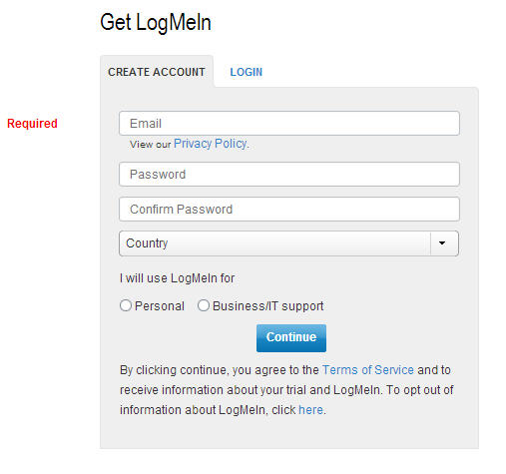
- Download & install Software
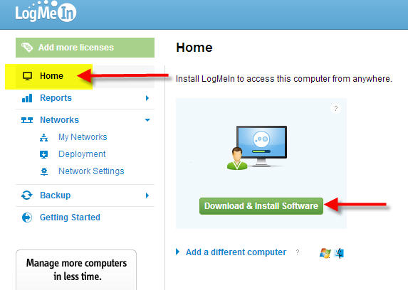
- Click Continue:
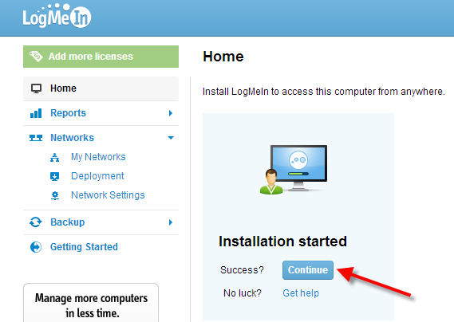
- Click Next on the Welcome screen:
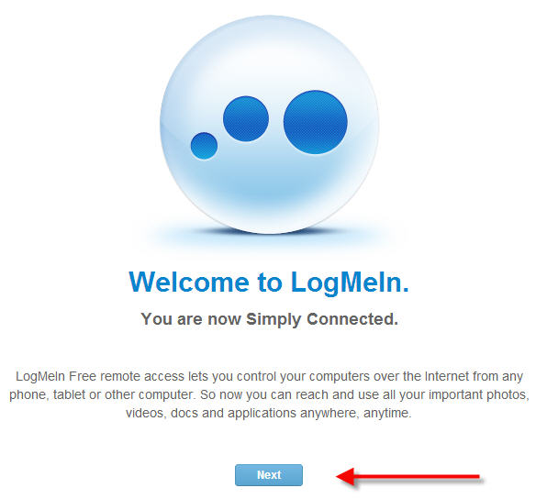
- Add This Computer
In this step you are required to do a few things. Download and Install the Client on any machine you wish to VPN into. Hamachi will trigger your Firewall and allow this file to download. Follow the installation Prompts then click NEXT a few times, then click Finish on web page.
NOTE: If running a firewall software, you may need to ensure that Hamachi is able to access the Internet. Please refer to the LogMeIn Hamachi Knowledge Base for up-to-date information for working with various popular security suites.

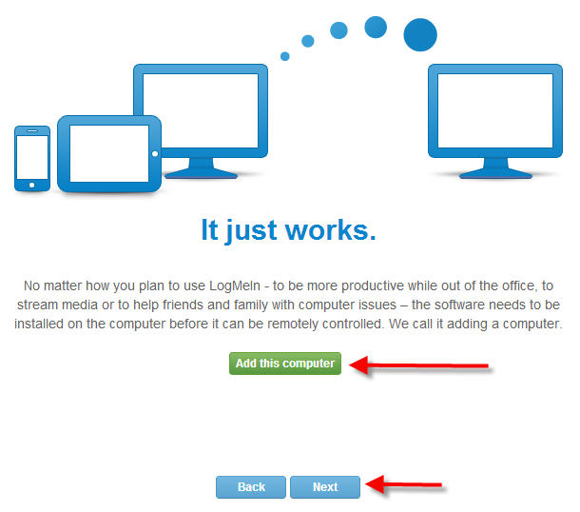
- Add a Network
You will need to name your Network and select “MESH” Type for best performance with D-Tools SIX, then click Continue:

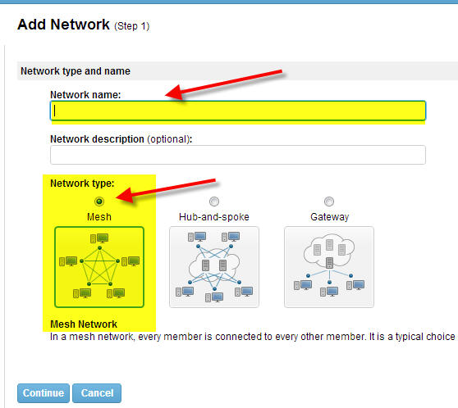
- Use the following settings on the next step:
- Accept Automatically,
- Check BOX = A passwords is required to join this network (security)
- Your preference on Subscriptions
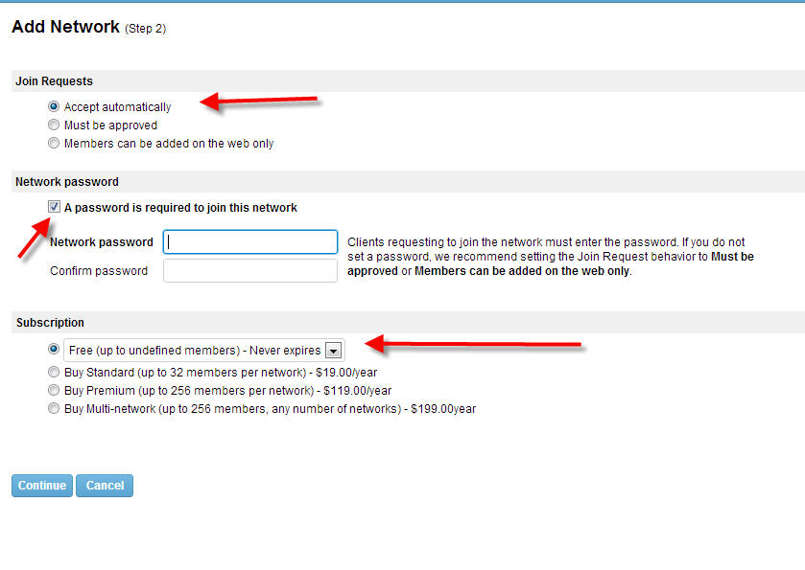
- Click Finish:
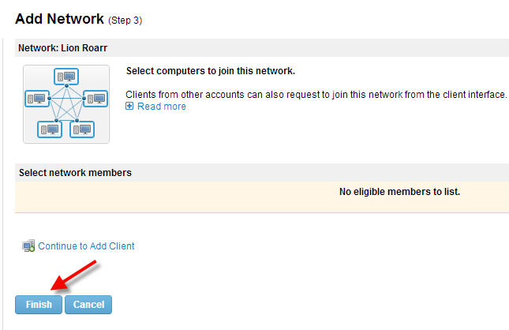

- Install the Hamachi Client on your laptop:
Follow this procedure to download and install the Hamachi client to separate computer. The client will be attached to your LogMeIn account. Client DOWNLOAD
NOTE: If running a firewall software, you may need to ensure that Hamachi is able to access the Internet. Please refer to the LogMeIn Hamachi Knowledge Base for up-to-date information for working with various popular security suites.
Important: You must be logged in to the LogMeIn account to which you want to attach the new Hamachi client.
1. On the LogMeIn web site, switch to Network mode and click Add Client.
The Add Client page is displayed.
2. Select Install LogMeIn Hamachi on this computer and click Continue
3. Click Install LogMeIn Hamachi.
The Hamachi installer is launched.
4. Follow the on-screen instructions.
The client is installed on the local computer as an attached member of the active LogMeIn account. You will be able to manage this client using the LogMeIn Hamachi FAQ help
- Add the Client to the Network
Double click your LogMeIn Hamachi icon and click the Network tab then Join an exciting network

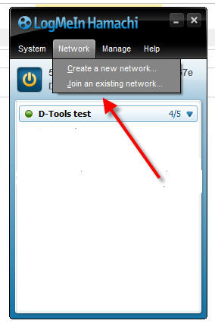
On this step you will see that the Client is prompting for Network ID and Password. The “Network ID” was automatically issued when you added a network in step 7.
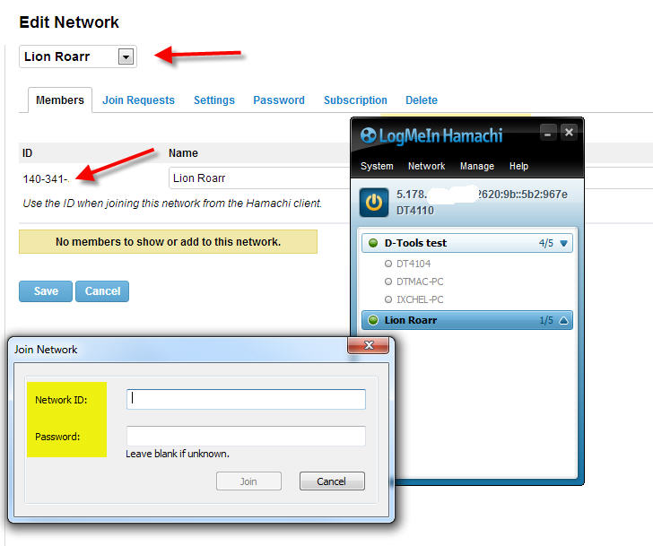

- Connect to D-Tools.
Launch SIX as you would normally, and click Start->Connect->Disconnect from Server
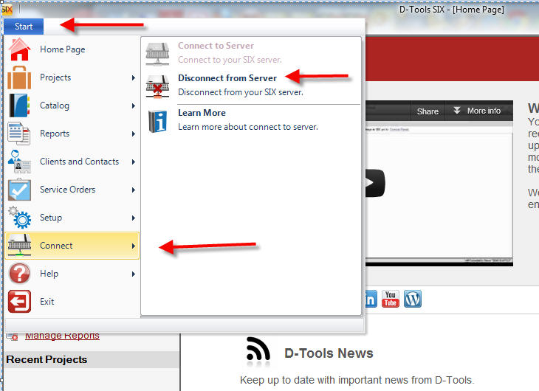

Here you will need to copy and paste the IP address from Hamachi to your server IP address field and Connect.
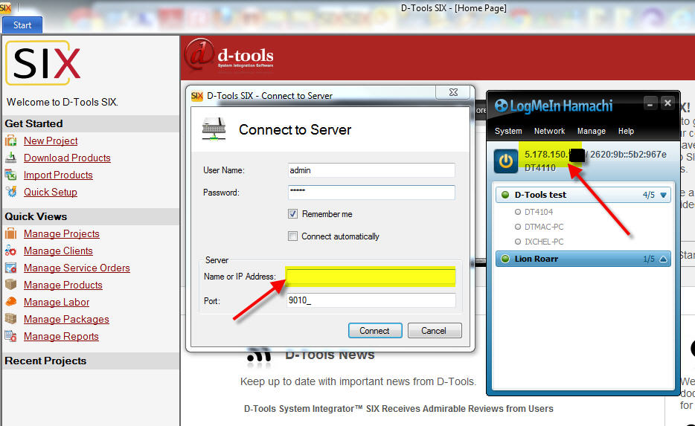

-Victor Chavez
D-Tools, Inc.

